PART-3 ASSIGNMENT-3

Create an API to collect data from URL (API Server)

Create a folder on desktop with a new file app.py to write the python script to create an API to collect data from URL

The GET method is used to collect data from the front end

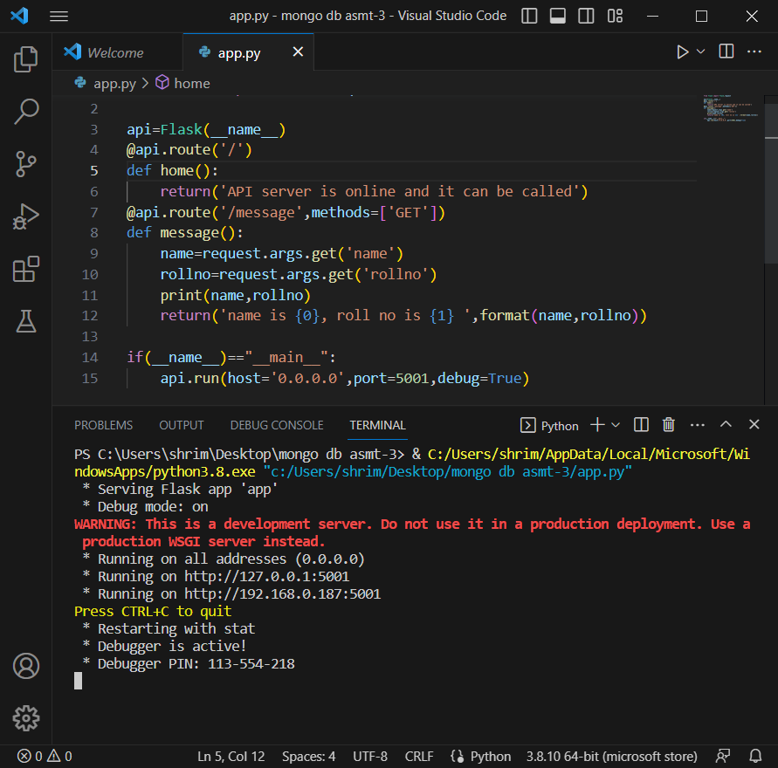

Copy the url of the server and open postman and paste it in the + button and click the send button

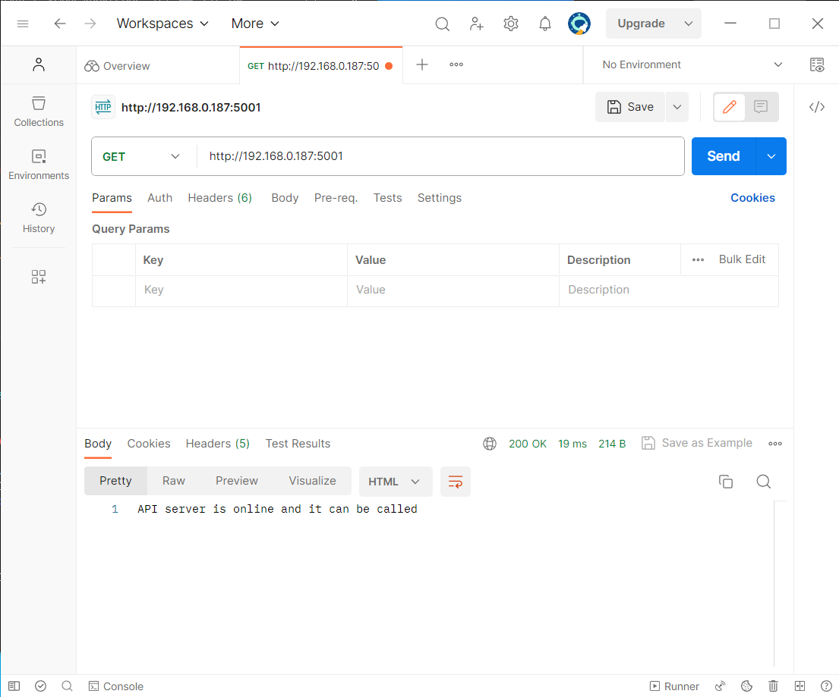

When key value pairs are given and see the path of message handler and the key values are appended to the url

This data is printed on server side and on api side

So there are two responses

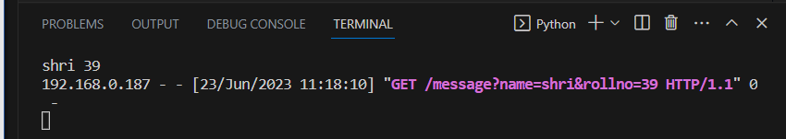

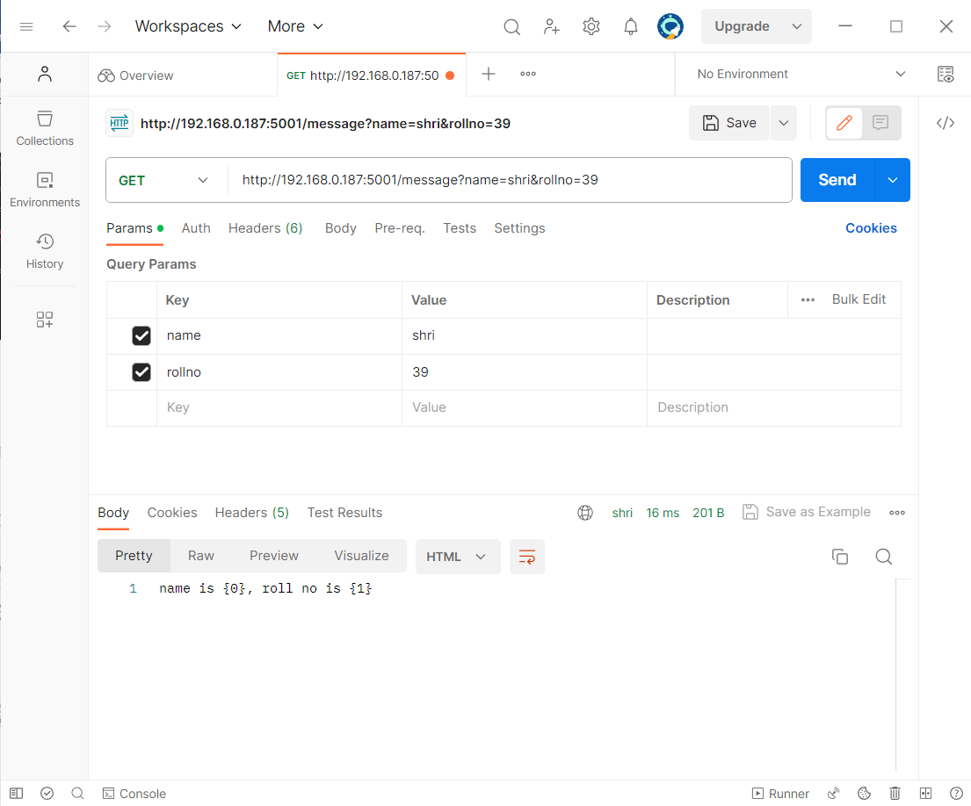

This way postman is used to append the key value pairs and this is how we create an API to collect data from URL in API server